**CP Club 365Days Challenge**

**Date – 12/12/2022**

**Programming language – C++**

**Problem Statement**

**[https://practice.geeksforgeeks.org/problems/balanced-array07200720/1?page=2&difficulty[]=-1&category[]=Arrays&sortBy=submissions](https://practice.geeksforgeeks.org/problems/balanced-array07200720/1?page=2&difficulty%5b%5d=-1&category%5b%5d=Arrays&sortBy=submissions)**

**Your Code**:

// 0x56Day of 0x365Days challenge

// VEDANT BHARAD

// 12-12-2022

//{ Driver Code Starts

#include <bits/stdc++.h>

#include<stdio.h>

#include<math.h>

using namespace std;

// } Driver Code Ends

class Solution

{

public:

    int minValueToBalance(int a[], int n)

    {

        int left=0,right=0,half=n/2;

        for(int loop=0;loop<half;loop++)

        {

            left=left+a[loop];

            right=right+a[half+loop];

        }

        return abs(right-left);

    }

};

//{ Driver Code Starts.

int main()

{

    int t;

    cin>>t;

    while(t--)

    {

        int n;

        cin>>n;

        int a[n];

        for(int i=0;i<n;++i)

            cin>>a[i];

        Solution ob;

        cout<<ob.minValueToBalance(a,n)<<endl;

    }

    return 0;

}

// } Driver Code Ends

**Output (Screen Shot)**:

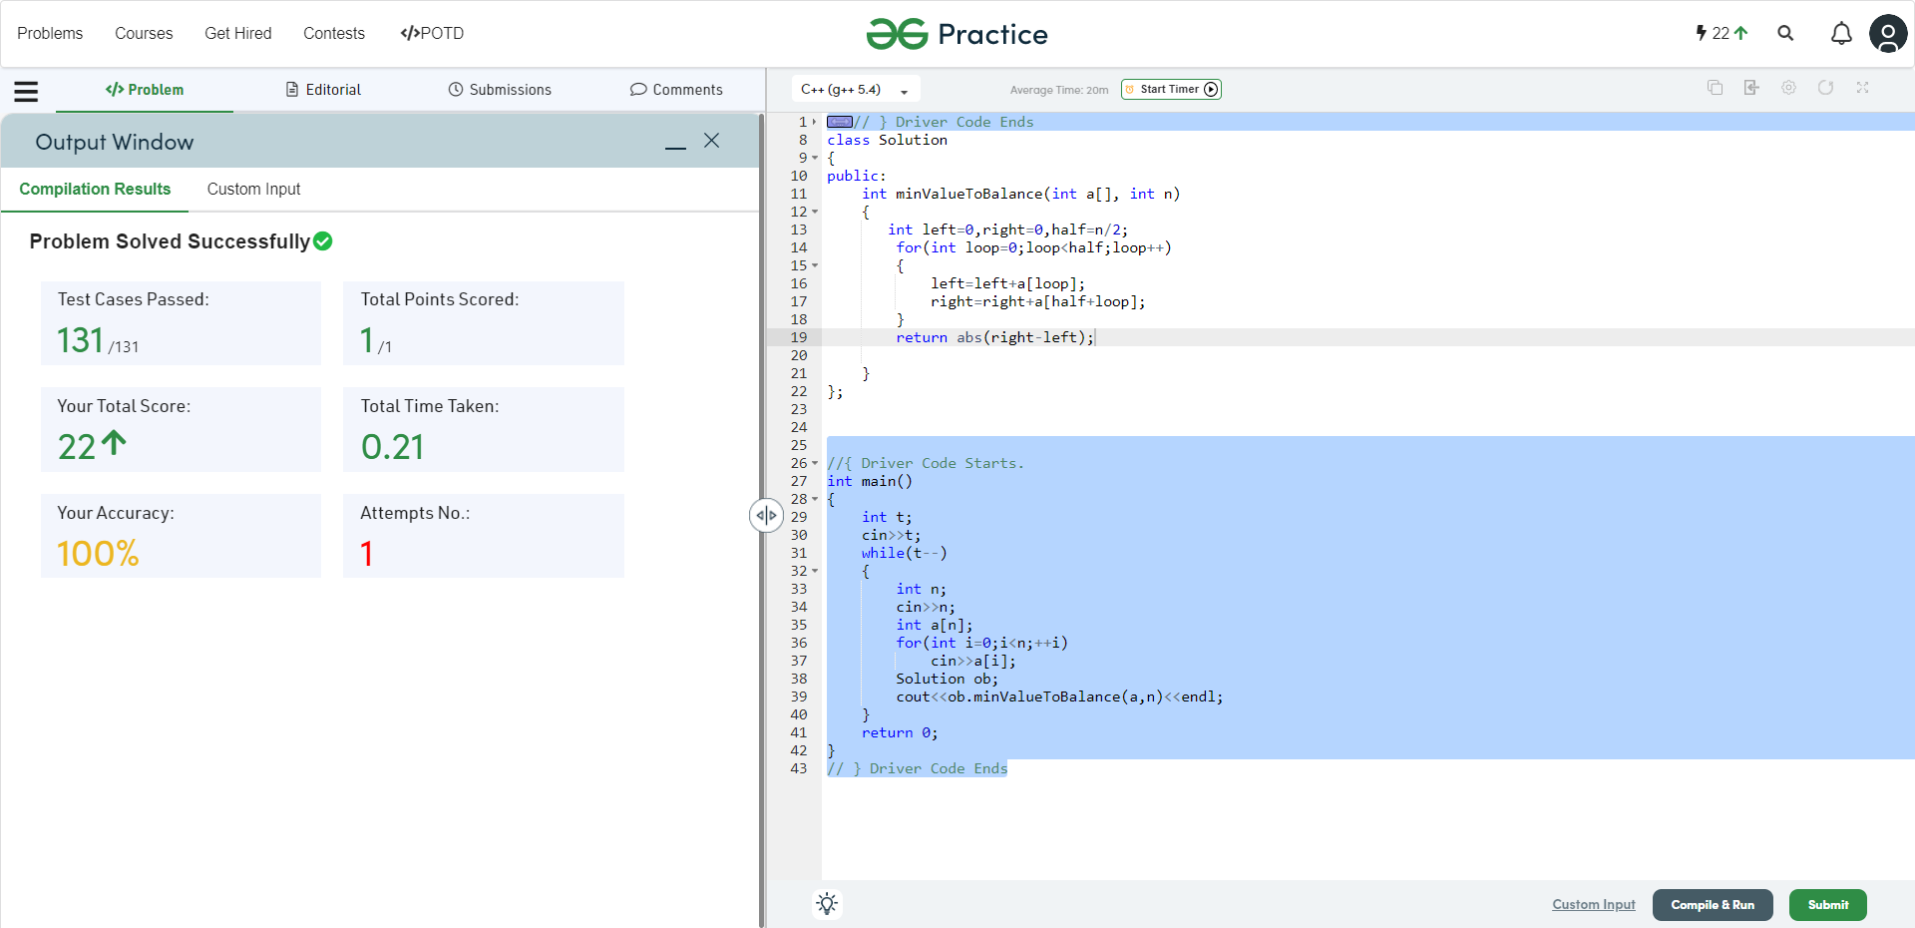

**Understanding about problem:**

* In this task I need to balanced the given array from half and for that find minimum value that can be added to an element so that array become balanced.

Note: If you can't understand the problem, feel free to contact us and we'll help you. Please don't copy and paste from anywhere.

ALL THE BEST

Team CP Club